Hereford Township
Annual Budget
Fiscal Year 2024

Board of Supervisors
John Membrino, Chairman
Keith Masemore, Vice Chairman
Karla Dexter

Secretary/Treasurer
Hannah Edwards

Table of Contents
Resolution adopting 2024 Budget | Page 03
Resolution adopting 2024 Real Estate Tax Rate | Page 04
2024 Budget Summary | Page 05
2023 Budget Summary by Fund | Page 06
Revenue Detail | Page 07
Revenue Spreadsheet | Page 10
Expense Detail 400 General Government | Page 13
Expense Spreadsheet 400 General Government | Page 15
Expense Detail 410 Public Safety | Page 16
Expense Detail 420 Health and Welfare | Page 16
Expense Spreadsheet 410 Public Safety and Health and Welfare | Page 17
Expense Detail 430 Highway, Roads, and Streets | Page 18
Expense Spreadsheet 430 Highway, Roads, and Streets | Page 20
State Liquid Fuel Budget Spreadsheet | Page 21
Expense Detail 440 Public Works Other Services | Page 22
Expense Detail 450 Recreation | Page 22
Expense Detail 470 Debt Service | Page 22
Expense Detail 480 Intergovernmental Expenditures | Page 22
Expense Spreadsheet 440, 450, 470, 480 | Page 23

Resolution 13- 2023

A resolution of the Township of Hereford, in the county of Berks, Commonwealth of Pennsylvania, Appropriating specific sums estimated to be required for the specific purpose of the municipal government, hereinafter set forth during the year 2024.

Be it resolved and enacted, and it is hereby resolved and enacted by the Board of Supervisors of the Township of Hereford, County of Berks, Commonwealth of Pennsylvania

Section 1: That for expenditures and expenses of the fiscal year 2024, the amounts are hereby appropriated from the fund equities, revenues, and other financing sources available for the year 2024 for the specific purposes set forth on the following pages.

Adopted the ____ day of December 2023

Hereford Township Board of Supervisors

__________________________
John Membrino, Chairman

___________________________
Keith Masemore

____________________________
Karla Dexter

Attest:

Hannah Edwards – Secretary / Treasurer
Resolution 14 – 2023

A resolution of the Township of Hereford, In the county of Berks, Commonwealth of Pennsylvania, Fixing the tax rate for the year 2024

Be it resolved and enacted, and it is hereby resolved and enacted by the Board of Supervisors of the Township of Hereford, County of Berks, Commonwealth of Pennsylvania:
Section 1: That a tax be and the same is hereby levied on all real property within the Township of Hereford subject to taxation for the fiscal year 2024 as follows:
General Purpose, the sum of on each dollar of assessed valuation, or the sum of on each one hundred dollars of assessed valuation
1.5000Mills (0.0015--)
0.15 cents
The same being summarized in tabular form as follows:
Mills on each Dollar of assessed valuation
Cents on each one hundred dollars of assessed.

Valuation tax rate of General Purposes
1.500 Mills (0.00150)
0.150 Cents

Adopted on the ___ day of December 2023

Hereford Township Board of Supervisors
_______________________________ - John Membrino, Chairman
_______________________________ - Keith Masemore
_______________________________ - Karla Dexter

_______________________________ - Hannah Edwards, Secretary/ Treasurer

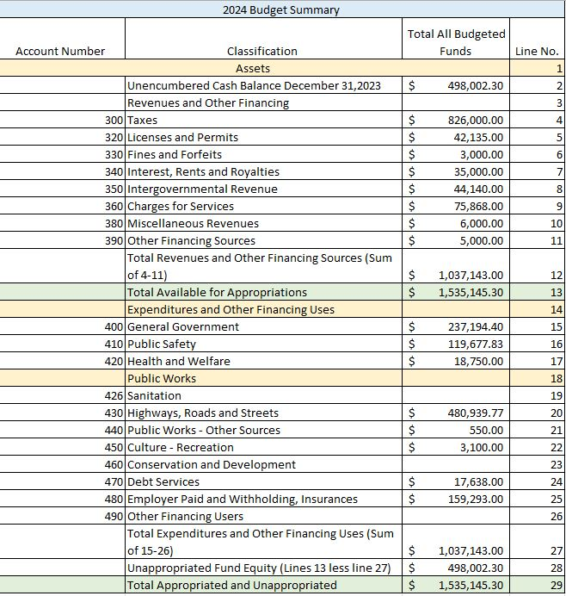

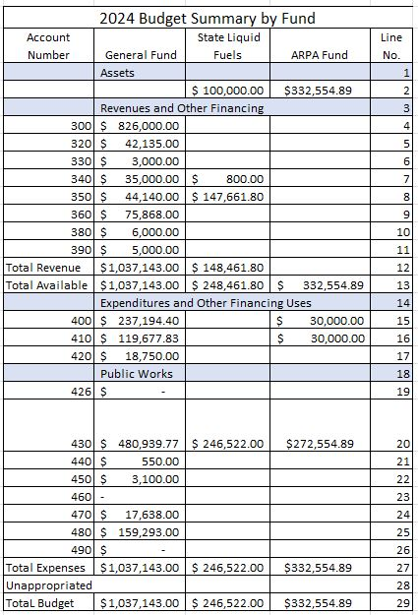

Revenue

American Rescue Plan Act - $332,554.89. Funds received in 2021 and 2022 must be allocated for expenditures by 2024.

300.00 – Taxes $826,000.00
This category includes real estate tax, real estate transfer tax, earned income tax, local services tax, and per capita tax.
Real Estate Tax – the current real estate tax rate is 1.58 mills for general purposes. Also, included in this category are delinquent real estate taxes paid to the Tax Claim Bureau and interim taxes paid on improvements to properties that result in higher assessments. The county has not reassessed property since 1994. The township raised real estate taxes in 2022. For the purpose of budgeting, a 95% collection rate is assumed and based on prior years.
Year: 2023 Assessed Value: $146,285,256.00 Billed Amount: $220,962.62 Millage: 0015
Per Capita Tax – Collected by Berkheimer, this tax is imposed on every member of a household eighteen years of age and older.
Real Estate Transfer Tax- the tax is ½% of the amount paid when a property is sold. There is currently a shortage of houses on the market which drove housing prices higher in 2023. With the increase in interest rates, the market may cool slightly. In the past, this budget number has been understated.
Earned Income Tax – this tax represents payments made on income earned by residents of the township. I am estimating a 4% increase in earned income tax revenue for 2024. This is based on an anticipated collection of $494,468.00 in 2023. With the increase in inflation, workers should see higher wage increases than in the past years.
Local Services Tax – there is an Act 511 tax formerly known as the Occupational Privilege Tax. A $52 fee is leveled on individuals working within the township boundaries and $47 of the $52 tax goes to the township to be used for emergency services and roads. The township just began using this tax in 2020. The budget number has been kept the same until we see a three-year average.
320.00 – Licenses and permits $42,135.00
This category includes licenses issued to campgrounds, junk yards and mobile home parks and the cable franchise fee. The cable franchise fee is 5% and levied on Service Electric and Comcast. This fee has begun to show a slight decline in recent years due to changes in household television options such as DISH and the growing prevalence of internet only households who watch television on sites like Hulu and Netflix rather than subscribing to cable television.

330.00 – Fines and forfeits $3,000.00
Category is comprised of fines for citations used by the district justice. The township no longer receives fines from the state police due to a policy that the state imposed in 2021 on municipalities without a police department.
340.00 – Rents and Royalties $35,000.00
Rents and Royalties include interest earned on all accounts and certificates of deposits, this increased drastically when we switched to PLGIT.
350.00 - State Shared Revenue $44,140.00 (General Fund) $147,661.80 (SLF)
State shared revenues are grants and aid received from the state and federal government.
American Rescue Plan Act - The final tranche of ARPA money will be received in September 2023. The US Treasury final rule allows all recipients to use the entire amount awarded to fund “government services.” All recipients may elect to use their standard allowance instead of calculating lost revenues, but funds must be allocated by 2024. Government services include any service traditionally provided by a government. I have accounted for the total amount of ARPA funds ($332,554.89) we currently hold on to the sheet titled Budget Summary by Fund online number 2 under General Fund.
Fire Co. Foreign Fire -This state aid is received on behalf of the two fire companies in the township and must be distributed within 30 days of the receipt. This is generally not considered revenue but is shown here for the benefit of the audit. The distribution of the same amount is shown under expense account 411.54 ($22,000.00)
Alcoholic Beverage License - Liquor license fees distributed by the state.
Pension State Aid - This state aid is applied for by March 31 of each year and must be used to pay the Pension MMO when received in October. Subject to audit by the State Auditors every three years.
State Game land Fee in Lieu of Tax- An annual payment-in-lieu- of-taxes (Pilot) to each affected school district, county, and municipality with state game lands within its boundaries.
Liquid Fuel – (This will be shown on a separate State Liquid Fuel Budget) Penn DOT calculates the state liquid fuel funds each year based on population, dedicated roadway miles and consumption. This money is required to be kept in a separate fund and spent only on Penn DOT approved expenditures such as road repair.
360.00 – General Government $75,868.00
General Government revenue includes charges for services such as the sale of copies, peddlers permit, and administration fees charged on new subdivisions and permit submissions. Line items highlighted in green are zoning and building permit fees received by the township that are paid to Technicon for their work as the township’s third-party code agency. The township has also entered into a snow removal contract (2021-2026) with Penn DOT and will be paid in exchange for maintenance of these items on the state roads. Other fees in this category include dog license fees and pavilion rental fees. The township receives fifty cents for each dog license sold.

380.00 – Miscellaneous Revenue $6,000.00
This category is used only for the reimbursement received from the District Township and Longswamp Township for their portion of the cost of workers compensation insurance paid for Seisholtzville Fire Company.
390.00 – Other Financing Sources $5,000.00
Sale of Mower on Municibid, estimating $5,000.00

Money held in reserve that is not included in this budget.
General Fund Ending 12/31/23 | $536,203.67
Capital Fund | $135,347.85
Money Market | $448,504.13
Certificate of Deposit | $263,881.24
Recreation Funds | $40,323.60
Total | $1,424,260.49

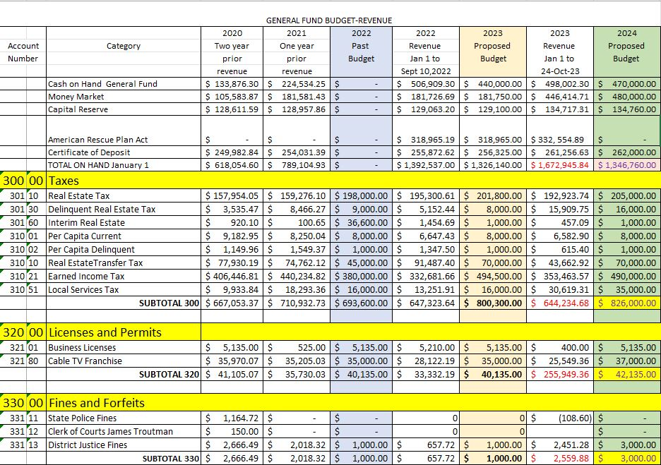

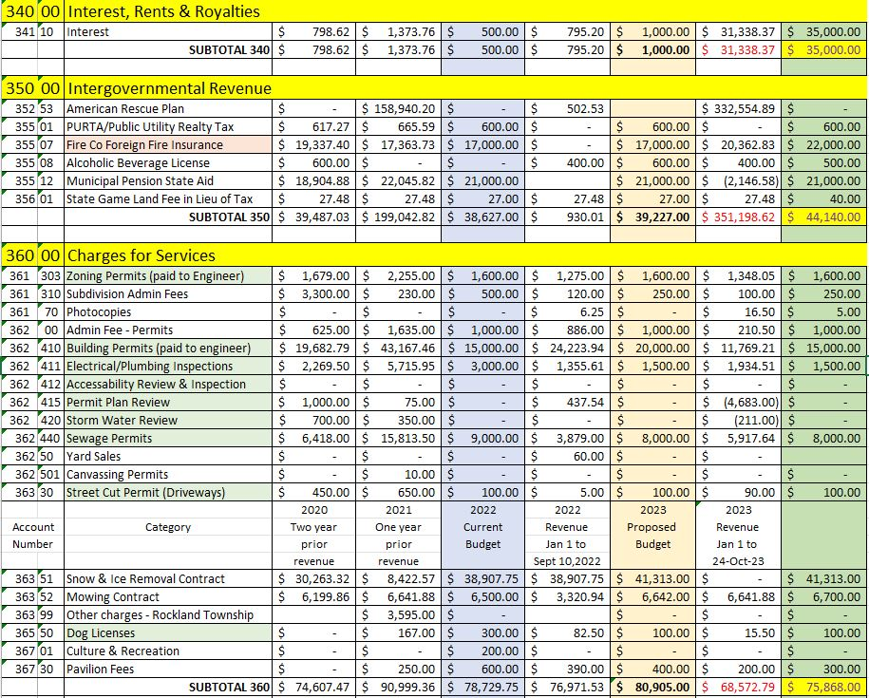
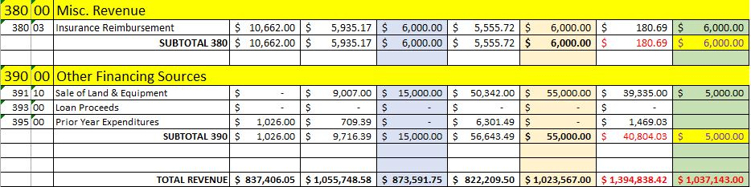

Expense
400.00 – General Government $237,194.40
Supervisors Pay - $62.50 per meeting- set by ordinance to a maximum of $1,875.00
Travel Expenses / Mileage – paid at the IRS approved rate for travel to the convention and meetings outside of the township.
Memberships Dues and Subscriptions
- Consv. District $100
- Country Public Works Association $75
- County Assoc Supervisors $75
- Town and Country $60
- Center for Comm. Leadership $250
- County Purchasing Council $150
- PSATS $1500
- UPV Chamber of Commerce $500
- Microsoft $510
- Adobe $120
- Back Blaze Computer Back up $60
- Zoom $100

Conferences and Education
1.PSATS conference
2. Trainings as needed for road crew or office staff.
Office Supplies – purchased through Office Service Co
Trash Removal – Township Bldg. Dumpster @ $150.00 a month
Postage
- 4 Newsletters – ($660 each)
- Postage – Roughly $60 a month every other month on average
Telephone
- Building phones is through Nextiva $102 a month.
- Cell phones are through AT&T $149.00 a month.
- Internet through Service Electric $83.00 a month.
Advertising
- Town and Country Newspaper are used for advertising.
- Meetings and Public Hearings, Ag security open enrollment, Audit Notice and Budget notice
Printing – Newsletter, four a year
Office Equipment and Maintenance
- Copier Lease $205 Monthly
- Computer Replacement $1500 / Chris computer was replaced in 2023, Back office is due in 2024 but can be postponed another year.
Bank/ Credit Card Fees – for direct deposit $16 month
Contracted Svc – computer support $100 hour.
Audit Service – annual audit of accounts by Barbara Akins CPA with a range between $7,920.00 and $8,315.00
Tax Collection
- Commission – the tax collector makes 5% on taxes collected – estimating a collection of $201,800.00 in real estate taxes.
- Supplies – is ½ the cost of the printing and mailing of the tax bills. This is a 50/50 split with the county of berks.
- Bond- the county provides a 4-year bond which was renewed in 2022.
Solicitor Fees – increase of 5% in hourly rate.
Secretary/Treasurer wages – 4% increase
Assistant Secretary wages – 4% increase
Treasurer Bonds – Bonds are for H. Edwards, L. Masemore and K. Masemore
Engineering Fees – Technicon estimates an increase of 5% in the hourly rate.
Building Supplies
- First Aide Kits
- Restroom supplies, trash bag
- Batteries
- Ice Melt
- AED
Fuel, Light and Water – Heating oil, propane, electric and water cooler rental
Building Repair and Maintenance
- Boiler inspection
- Cleaning service for township building
- Fire Extinguisher service
- Generator Maintenance
- Furnace annual service
- Metal Roof Replacement
- Security Monitoring – Historical society office

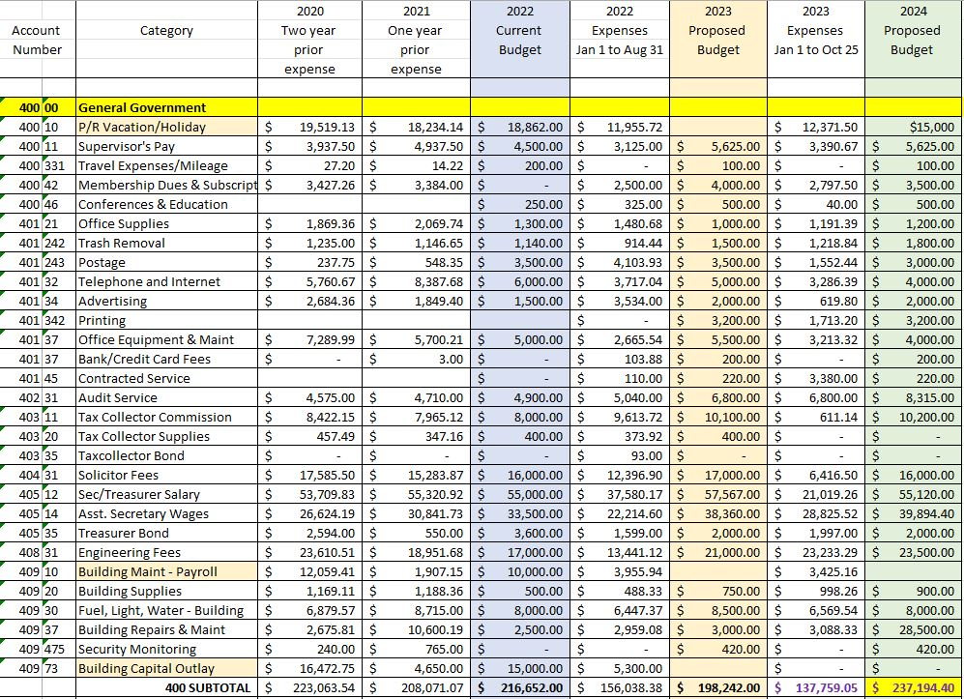
410.00 – Public Safety $119,677.83
Fire Fighters Relief – money received from the state to be distributed to the fire company for use on equipment and training.
ARPA funds - distributed to Hereford Fire Company and Seisholtzville Fire Company, this will be a one-time transfer of $15,000.00 to each company.
Ambulance – the township donates to Bally Ambulance every year. $8,500.00
Building permits and inspections – covered by the collected building permit fees.
911 Dispatching – cost is tied to consumer price index – all urban consumers for the northeast region which in July 2020 was 7.3%.
Zoning Hearing Expenses – are fees for half the cost of the stenographer and the zoning hearing solicitor. $2,000.00
Zoning Permits and Code Enforcement – partially covered by zoning permit fees.
Dangerous Tree Removal - costs associated with the removal of dangerous trees outside of road crew wages and equipment rental. This would be materials, training, contractors hired to perform the work.
ZBH payroll – the zoning hearing board three members is each paid a stipend of $35 per hearing. I have budgeted for three hearings.
Contributions to Fire Companies includes both Hereford Fire Company and Seisholtzville Fire Company along with their fire police.
- Each company fire police receives $1300.
- Proposing Seisholtzville receive a $3,000 fuel allowance and Hereford receive $3,000 fuel allowance based on their usage and to assist with raising cost.
- Both fire companies received equal amounts and I have budgeted $43,000 for the board to split
- In 2023 the census shows Hereford Township having 1188 households and Hereford Fire Company has 1117 households in its service area on their mailing list.
420.00 – Health and Welfare $18,750.00
Sewage enforcement – the cost is mostly covered through permit fees.
Contributions to Human Services includes the following donations:
- Berks Visiting Nurses($50 2023)
- Perk Up $500
- Boyertown Multiservice ($100 2023)
Dog Licenses – are covered by the fees collected.
Act 537 Plan – the expenses associated with development of the Act 537 Plan not covered by escrowed funds.

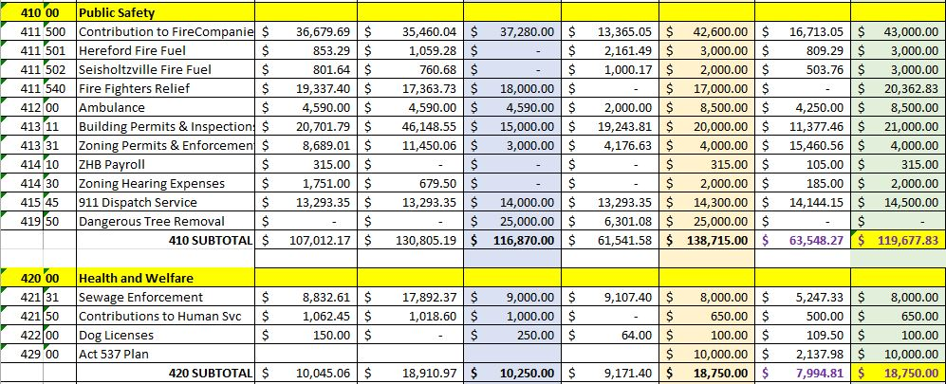
430.00 – Highways, Roads, and Streets $480,939.77 General Fund and $265,522.00 SLF
Supplies
Clothing General Expense
- Allowance is $500 a piece for 3 employees.
- T- Shirt and Sweatshirt with logo
Vehicle Operation
- Fuel
- Inspection, oil, filters, and fluids
- Radios
Utility Marking – PA One Call Charges
Capital Equipment – Co-op Equipment
- Towards used equipment $7,500
- Towards used trailer $15,000
Snow and Ice Removal Payroll
Snow Materials and Supplies
- Antiskid, mag and salt
- Snow fence and Mailbox repair
Line Painting Payroll
Sign Supplies
- Street index, traffic signs
- Barricades and cones
- Paint for line painting
Traffic Signal
- Traffic signal maintenance and repair $820.00
- Traffic Signal - $40 a month

Street Light Electric

Equipment Maintenance Payroll

Equipment Rental – lift, crane, or bucket truck for tree removal

Road Maintenance Payroll –all road crew wages are put in this line to be filtered out to the other payroll lines as desired.

Road Maintenance Supplies
- Crack seal
- Spring Hill Road Drainage repair – pipe, stone, and topsoil
- Camp Mensch Mill
Road Work – from State Liquid Fuel Budget $159,000.00
- Long Lane
- Hock Road
- Hert Lane
New Equipment
- John Deer Tractor $151,758.00
- Mowing Attachment $103,816.48
Loader Lease – payment will be $52,565.43 for a five-year lease.

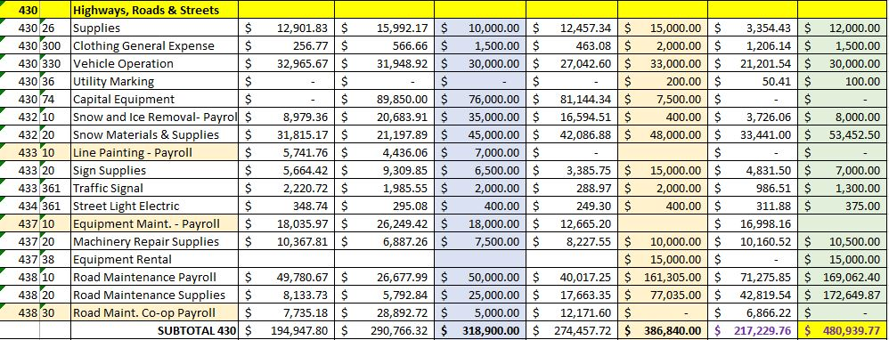
State Liquid Fuel
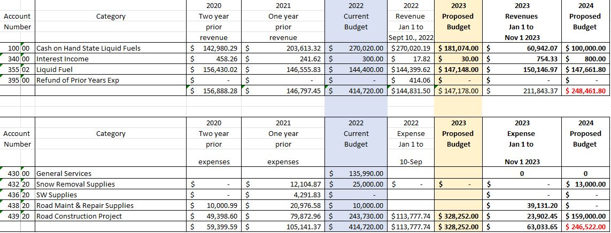

440.00 – Public Works Others Services $550.00
Fire Hydrants – KOB inspection
450.00 – Recreation $3,100.00
Park Supplies
- Dog waste bags
- Restroom Supplies
- Mulch if needed.
Parks Contracted Service
Donations to Library – Schwenkfelder Library $500
470.00 – Debt Service $17,638.00
Asphalt Zipper Lease – the payment is split 4 ways will be $17,213.00 This would be a 5-year lease with three municipalities participating in the lease.
Loader Lease – payment will be $52,565.43 for a five-year lease – Funds from 430.00
480.00 – Intergovernmental Expenditures $159,293.00
Workers Compensation Insurance - $25,000.00
Unemployment Compensation - Based on a 4% raise.
Health Insurance - 2.4% increase from last year $58,800.00
Vison – 3% increase from last year $6.12 per person
Dental - $3,390.00
Life - $485.00
Disability - $815.00
Pension Obligation – $25,543.00
FICA – Employer based on a 4% raise $16,900.00.
Property and Liability Insurance – Per agent, estimate a 6% increase $25,000.00.

